**CARESTREAM HEALTH**

|  |  |
| --- | --- |
| **Part Number :** | **Autour : Ralf Wang** |
| **Project : KIOSK PUMA System** | **Product : KIOSK** |
| **Document Title: Kiosk PUMA Reliability Testing Report** | |

**TABLE OF CONTENTS**

[1 Test Environment 2](#_Toc488064487)

[2 Test Requirement 2](#_Toc488064488)

[2.1 Test Scenario 3](#_Toc488064489)

[2.2 Test Tool 3](#_Toc488064490)

[3 Testing work （Phase 1） 4](#_Toc488064491)

[3.1 Strategy and Scenario Setting 4](#_Toc488064492)

[3.2 Background Data 4](#_Toc488064493)

[3.3 Other Setting: 5](#_Toc488064494)

[3.3.1 Database setting 5](#_Toc488064495)

[3.3.2 IIS setting 5](#_Toc488064496)

[3.4 Test Object version 5](#_Toc488064497)

[3.5 Test result 5](#_Toc488064498)

[3.5.1 Test Statistic Report 5](#_Toc488064499)

[3.5.2 Transaction summary result: 6](#_Toc488064500)

[3.5.3 Transaction response time result 7](#_Toc488064501)

[3.6 Bottleneck analysis 7](#_Toc488064502)

[3.6.1 Hardware usage analysis 7](#_Toc488064503)

[3.6.2 SQL Server resource usage analysis 9](#_Toc488064504)

[3.7 Test Error 11](#_Toc488064505)

[3.8 Test Conclusion 11](#_Toc488064506)

# Test Environment

Test environment：We use the following machine to do our performance testing work.

|  |  |  |  |  |  |  |  |  |  |  |  |
| --- | --- | --- | --- | --- | --- | --- | --- | --- | --- | --- | --- |
| **Server Name** | **Type** | **CPU** | | **Hard Disk** | | **RAM** | | **OS** | | **Required Software** | |
| PS Server | Hyper-v virtual machine | Intel Xeon E5-2620 v3 2.40GHz \*12 | 2T SCSI Disk  Seagate MD3002 | | 32G | | Windows 2012 R2 | | SQL 2012  IIS 8 | |
| QTP script machine | Hyper-v virtual machine | Intel Xeon E5-2403 v2 1.80GHz \*4 | 80G Virtual Disk | | 2.5G | | Windows 2012 R2 | | QTP 11 demo | |
| Performance control | Dell optiplex 9020 | Intel core(TM) i7-4790 3.6GHZ\*6 | 1T SATA Disk | | 8G | | Win7 64bit | | Load runner | |

Figure 1.1 Hardware List

# Test Requirement

The PUMA system will support reporting and notice push service for different departments of entire hospital. We will integrate with the 3rd party system, as a result, patients can print their reports in ONE terminal. The message push service will also be included in the product. Patient can require different information and get the report status notice service from the product.

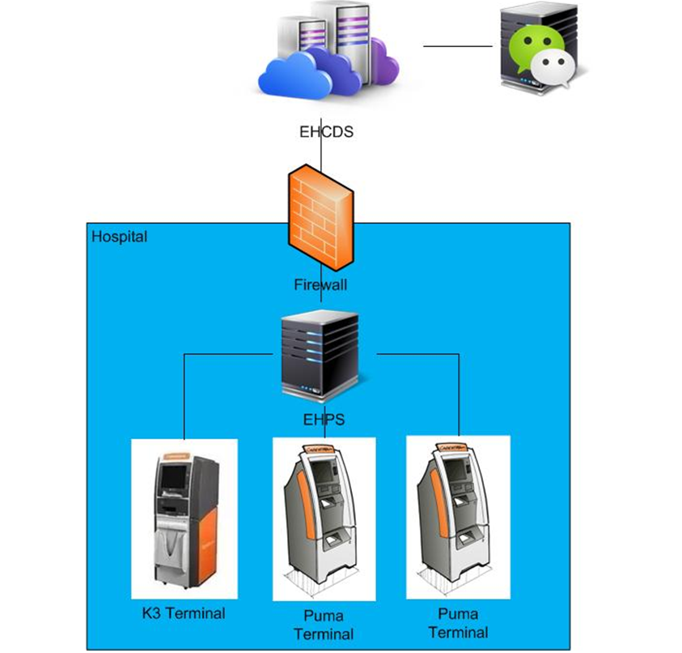

Figure2.1 System structure

We will do the reliability testing work to ensure the system can meet the requirements and services work well. The detail plan and strategy please refer to the content in document as follows:



## Test Scenario

The testing work will simulate the real work flow include Print film from workstation, OCR operations, terminal print film, terminal print report and etc.

## Test Tool

QTP: Simulate doctor print film from workstation.

Load Runner: Simulate the doctor and patient operation by http or web service.

# Testing work （Phase 1）

## Strategy and Scenario Setting

1. Use automation tool simulate the doctor print film work. Simulate 8 GX Platform by using QTP and PDSender tool. Each client prints one film which size is 10MB every 30 seconds.
2. Use LR tool simulate 8 K2/K3 terminals to print film. Each client prints one film which size is 10MB randomly from 5 to 30 seconds.
3. Use LR tool simulate 45 PUMA terminals to print paper reports. Each client prints report randomly from 5 to 30 seconds.
4. Use LR tool simulate the PUMA report archive operations. Each client archive report in random 5 to 30 seconds and size is random with 100kb and 4Mb.
5. The OCR setting is cover the rule for GX platforms in step1 and other setting are set as default.
6. Execute QTP script to simulate a real terminal to print 100 patient`s report as cycle.
7. Monitor the hardware resource usage on PS.
8. Monitor the resource usage for database on PS.
9. Start/Stop 2 virtual users every 5 seconds and run the scenario for 7\*24 hours.

## Background Data

We use SQL command statement to add large data in the database, the detail information as follows:

|  |  |
| --- | --- |
| **Table Name** | **Data Volume (records)** |
| printer.dbo.DeliveryJob | 896813 |
| printer.dbo.ImageBox | 997879 |
| printer.dbo.Page | 997813 |
| printer.dbo.Session | 1001132 |
| wggc.dbo.Patient | 1029777 |
| wggc.dbo.Study | 1029789 |
| wggc.dbo.AFP\_PrintTerminalInfo | 62 |
| wggc.dbo.Series | 1029735 |
| wggc.dbo.Image | 1029738 |
| wggc.dbo.AFP\_FilmInfo | 1043592 |
| wggc.dbo.AFP\_ReportInfo | 936761 |
| wggc.dbo.AFP\_ExamInfo | 1997005 |
| wggc.dbo.AFP\_PrintTask | 3696324 |
| wggc.dbo.T\_Integration\_ExamInfo | 119292 |
| AFP\_PrintMode | 87883 |
| wggc.dbo.vi\_KIOSK\_ExamInfo\_Order | 119331 |

Figure 3.2.1 Background Data

## Other Setting:

### Database setting

Memory: Set the min and max memory size to 8GB.

Index fill factor: 80.

File: Increase the data and log files size and the rule is increase 500Mb as fixed size.

### IIS setting

Connection: Keep with setting which change by the PS install package.

## Test Object version

KIOSK Platform 3.0.0.1 B0801

Developer team updated some SQL statement, add some no lock operates in the SQL. It seems enhance the performance of the PS system.

## Test result

### Test Statistic Report

|  |
| --- |
| Statistics Summary |

|  |  |  |
| --- | --- | --- |
| [**Maximum Running Vusers:**](file:///C:\Users\19005260\AppData\Local\Administrator\AppData\Local\Temp\VuserStateGraph) |  | 98 |
| [**Total Hits:**](file:///C:\Users\19005260\AppData\Local\Administrator\AppData\Local\Temp\HitsperSecond) | [Description: Show SLA Results](slarules:total_hits) | 656,499 |
| [**Average Hits per Second:**](file:///C:\Users\19005260\AppData\Local\Administrator\AppData\Local\Temp\HitsperSecond) | [Description: Show SLA Results](slarules:average_hits) | 11.061 | [**View HTTP Responses Summary**](file:///C:\Users\19005260\AppData\Local\Administrator\AppData\Local\Temp\1091964346.html#1) |
| [**Total Errors:**](file:///C:\Users\19005260\AppData\Local\Administrator\AppData\Local\Temp\TotalErrorsPerSecond) | [Description: Show SLA Results](slarules:errors_per_second) | 358 |  |

|  |
| --- |
| Transaction Summary |

|  |  |  |  |  |
| --- | --- | --- | --- | --- |
| [**Transactions:**](file:///C:\Users\19005260\AppData\Local\Administrator\AppData\Local\Temp\TransactionSummary) | Total Passed: 744,934 | Total Failed: 88 | Total Stopped: 15 | [**Average Response Time**](file:///C:\Users\19005260\AppData\Local\Administrator\AppData\Local\Temp\ResponseTime) |

|  |  |  |  |  |  |  |  |  |  |
| --- | --- | --- | --- | --- | --- | --- | --- | --- | --- |
| **Transaction Name** | **SLA Status** | **Minimum** | **Average** | **Maximum** | **Std. Deviation** | **90 Percent** | **Pass** | **Fail** | **Stop** |
| [Create New Patient](file:///C:\Users\19005260\AppData\Local\Administrator\AppData\Local\Temp\ResponseTime0000(Create%20New%20Patient)0000) | [Description: Show SLA Results](slarules:transaction_response_time_CreateNewPatient) | 0.286 | 0.829 | 5.031 | 0.416 | 1.177 | 89,924 | 0 | 0 |
| [Film Create\_PrintTask](file:///C:\Users\19005260\AppData\Local\Administrator\AppData\Local\Temp\ResponseTime0000(Film%20Create_PrintTask)0000) | [Description: Show SLA Results](slarules:transaction_response_time_FilmCreate_PrintTask) | 0.016 | 0.105 | 8.434 | 0.174 | 0.164 | 8,454 | 0 | 0 |
| [Film PrintTask](file:///C:\Users\19005260\AppData\Local\Administrator\AppData\Local\Temp\ResponseTime0000(Film%20PrintTask)0000) | [Description: Show SLA Results](slarules:transaction_response_time_FilmPrintTask) | 0.14 | 1.15 | 6.842 | 0.573 | 1.775 | 8,454 | 0 | 0 |
| [Film PrintTask\_Result\_Correct](file:///C:\Users\19005260\AppData\Local\Administrator\AppData\Local\Temp\ResponseTime0000(Film%20PrintTask_Result_Correct)0000) | [Description: Show SLA Results](slarules:transaction_response_time_FilmPrintTask_Result_Correct) | 0 | 0 | 0.016 | 0 | 0 | 8,452 | 0 | 0 |
| [Film PrintTask\_Result\_Fail](file:///C:\Users\19005260\AppData\Local\Administrator\AppData\Local\Temp\ResponseTime0000(Film%20PrintTask_Result_Fail)0000) | [Description: Show SLA Results](slarules:transaction_response_time_FilmPrintTask_Result_Fail) | 0 | 0 | 0 | 0 | 0 | 0 | 2 | 0 |
| [Film TerminalStatus](file:///C:\Users\19005260\AppData\Local\Administrator\AppData\Local\Temp\ResponseTime0000(Film%20TerminalStatus)0000) | [Description: Show SLA Results](slarules:transaction_response_time_FilmTerminalStatus) | 0.016 | 0.082 | 2.732 | 0.075 | 0.125 | 16,908 | 0 | 0 |
| [Film\_PrintStatus\_CheckService](file:///C:\Users\19005260\AppData\Local\Administrator\AppData\Local\Temp\ResponseTime0000(Film_PrintStatus_CheckService)0000) | [Description: Show SLA Results](slarules:transaction_response_time_Film_PrintStatus_CheckService) | 0.017 | 0.08 | 6.954 | 0.113 | 0.121 | 23,896 | 0 | 0 |
| [Notify File 100k](file:///C:\Users\19005260\AppData\Local\Administrator\AppData\Local\Temp\ResponseTime0000(Notify%20File%20100k)0000) | [Description: Show SLA Results](slarules:transaction_response_time_NotifyFile100k) | 0.987 | 11.234 | 26.454 | 2.833 | 15.008 | 88,107 | 86 | 0 |
| [Notify File 4M](file:///C:\Users\19005260\AppData\Local\Administrator\AppData\Local\Temp\ResponseTime0000(Notify%20File%204M)0000) | [Description: Show SLA Results](slarules:transaction_response_time_NotifyFile4M) | 2.342 | 11.451 | 29.657 | 3.761 | 16.63 | 1,731 | 0 | 0 |
| [Report QueryFilmReportInfo](file:///C:\Users\19005260\AppData\Local\Administrator\AppData\Local\Temp\ResponseTime0000(Report%20QueryFilmReportInfo)0000) | [Description: Show SLA Results](slarules:transaction_response_time_ReportQueryFilmReportInfo) | 0.007 | 0.039 | 0.12 | 0.011 | 0.053 | 199,591 | 0 | 5 |
| [Report TerminalStatus](file:///C:\Users\19005260\AppData\Local\Administrator\AppData\Local\Temp\ResponseTime0000(Report%20TerminalStatus)0000) | [Description: Show SLA Results](slarules:transaction_response_time_ReportTerminalStatus) | 0.027 | 0.083 | 1.482 | 0.048 | 0.117 | 199,608 | 0 | 10 |
| [Report Update report printer info](file:///C:\Users\19005260\AppData\Local\Administrator\AppData\Local\Temp\ResponseTime0000(Report%20Update%20report%20printer%20info)0000) | [Description: Show SLA Results](slarules:transaction_response_time_ReportUpdatereportprinterinfo) | 0.067 | 0.144 | 3.521 | 0.099 | 0.197 | 99,809 | 0 | 0 |

Figure 3.5.1.1 Summary Report

Follow the summary result information: we can get the information that:

We stop the testing work because there are some errors happened during the testing work.

The whole testing work lasts for 16 hours and 29 minutes. There are 74,934 transactions passed, 88 transactions failed and 15 virtual users stop execute. The following transactions which response times not meet the requirements and value is large:

|  |  |  |  |  |  |  |  |  |  |
| --- | --- | --- | --- | --- | --- | --- | --- | --- | --- |
| **Transaction Name** | **SLA Status** | **Minimum** | **Average** | **Maximum** | **Std. Deviation** | **90 Percent** | **Pass** | **Fail** | **Stop** |
| [Film PrintTask\_Result\_Fail](file:///C:\Users\19005260\AppData\Local\Administrator\AppData\Local\Temp\ResponseTime0000(Film%20PrintTask_Result_Fail)0000) | [Description: Show SLA Results](slarules:transaction_response_time_FilmPrintTask_Result_Fail) | 0 | 0 | 0 | 0 | 0 | 0 | 2 | 0 |
| [Notify File 100k](file:///C:\Users\19005260\AppData\Local\Administrator\AppData\Local\Temp\ResponseTime0000(Notify%20File%20100k)0000) | [Description: Show SLA Results](slarules:transaction_response_time_NotifyFile100k) | 0.987 | 11.234 | 26.454 | 2.833 | 15.008 | 88,107 | 86 | 0 |
| [Notify File 4M](file:///C:\Users\19005260\AppData\Local\Administrator\AppData\Local\Temp\ResponseTime0000(Notify%20File%204M)0000) | [Description: Show SLA Results](slarules:transaction_response_time_NotifyFile4M) | 2.342 | 11.451 | 29.657 | 3.761 | 16.63 | 1,731 | 0 | 0 |

Figure 3.5.1.1 value of response time

The team should focus on the tuning works to enhance the service reliability and find out the reason why some transactions are failed.

### Transaction summary result:

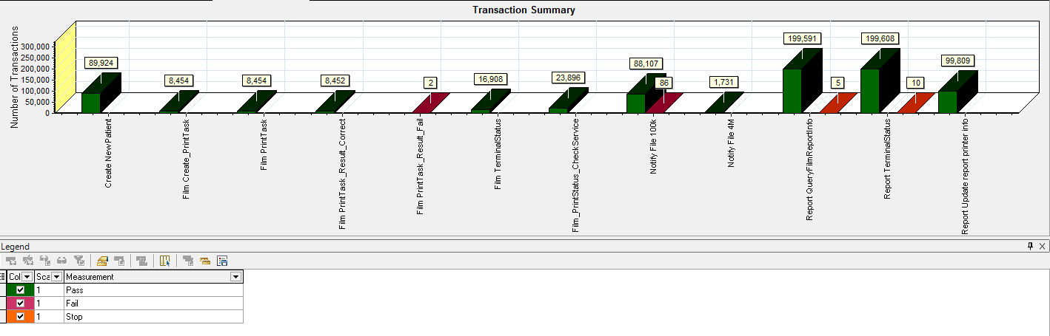

Figure 3.5.2.1 Transaction Summary

We notice that there are some transactions failed during the testing work. We should find out the reason and fix it in the next version.

### Transaction response time result

We can get the transactions’ response time information from the figure as follow:

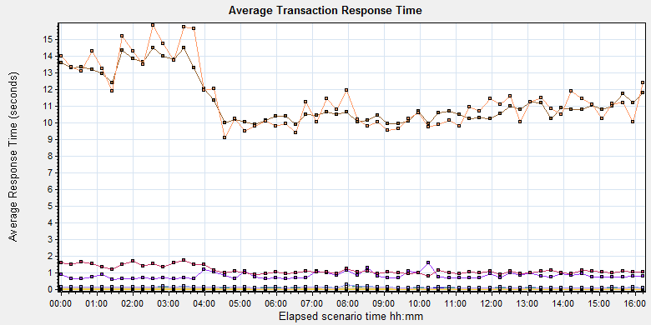

|  |  |  |  |  |  |  |  |
| --- | --- | --- | --- | --- | --- | --- | --- |
| **Color** | **Scale** | **Measurement** | **Graph's Minimum** | **Graph's Average** | **Graph's Maximum** | **Graph's Median** | **Graph's Std. Deviation** |
|  | 1 | Create New Patient | 0.624 | 0.827 | 1.614 | 0.746 | 0.195 |
|  | 1 | Film Create\_PrintTask | 0.072 | 0.105 | 0.309 | 0.095 | 0.033 |
|  | 1 | Film PrintTask | 0.814 | 1.154 | 1.765 | 1.068 | 0.235 |
|  | 1 | Film PrintTask\_Result\_Correct | 0 | 0 | 0 | 0 | 0 |
|  | 1 | Film TerminalStatus | 0.061 | 0.082 | 0.175 | 0.074 | 0.021 |
|  | 1 | Film\_PrintStatus\_CheckService | 0.058 | 0.08 | 0.2 | 0.069 | 0.025 |
|  | 1 | Notify File 100k | 9.863 | 11.304 | 14.486 | 10.767 | 1.404 |
|  | 1 | Notify File 4M | 9.09 | 11.45 | 15.824 | 11.1 | 1.779 |
|  | 1 | Report QueryFilmReportInfo | 0.032 | 0.039 | 0.046 | 0.038 | 0.003 |
|  | 1 | Report TerminalStatus | 0.064 | 0.082 | 0.149 | 0.073 | 0.018 |
|  | 1 | Report Update report printer info | 0.114 | 0.142 | 0.277 | 0.131 | 0.031 |

Description: C:\Users\Administrator\AppData\Local\Temp\Report\dot_trans.gif

|  |
| --- |
| **Description:**Displays the average time taken to perform transactions during each second of the load test. This graph helps you determine whether the performance of the server is within acceptable minimum and maximum transaction performance time ranges defined for your system. |
|  |

|  |
| --- |
|  |
|  |

Figure 3.5.3.1 Transaction response time

This figure shows all transactions’ response time. We can analysis that there are four transaction time very big which mentioned in chapter 3.5.1. There are: Notify File 4M, Notify File 100k. The service for these transactions should be enhanced.

## Bottleneck analysis

### Hardware usage analysis

During the testing work, we use the test tool to monitor the server hardware usage include the CPU, Memory, hard disk and etc.

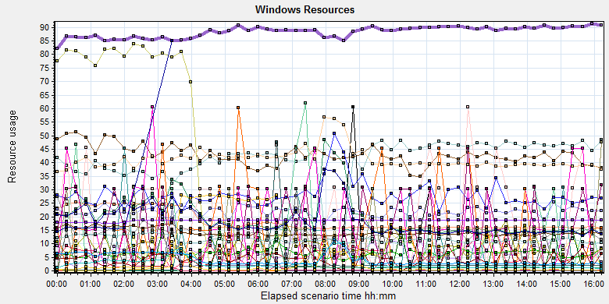

|  |  |  |  |  |  |  |
| --- | --- | --- | --- | --- | --- | --- |
| **Color** | **Scale** | **Measurement** | **Minimum** | **Average** | **Maximum** | **Std. Deviation** |
|  | 0.1 | % Disk Read Time (PhysicalDisk \_Total):10.184.129.208 | 0 | 14.08 | 10617.983 | 146.372 |
|  | 0.1 | % Disk Time (PhysicalDisk \_Total):10.184.129.208 | 22.407 | 197.435 | 12020.796 | 269.858 |
|  | 0.1 | % Disk Write Time (PhysicalDisk \_Total):10.184.129.208 | 22.013 | 183.355 | 11298.787 | 187.305 |
|  | 1 | % Idle Time (PhysicalDisk \_Total):10.184.129.208 | 0 | 40.951 | 81.077 | 18.329 |
|  | 1000 | % Interrupt Time (Processor \_Total):10.184.129.208 | 0 | 0.043 | 0.859 | 0.047 |
|  | 10 | % Privileged Time (Processor \_Total):10.184.129.208 | 0.086 | 1.834 | 4.573 | 0.552 |
|  | 10 | % Processor Time (Process AcquisitionServer):10.184.129.208 | 0 | 2.106 | 26.564 | 4.22 |
|  | 10000 | % Processor Time (Process auditServer):10.184.129.208 | 0 | 0.002 | 1.036 | 0.031 |
|  | 100 | % Processor Time (Process AutoDeliveryServer):10.184.129.208 | 0 | 0.219 | 2.604 | 0.338 |
|  | 1000 | % Processor Time (Process AutoForwardFilmService):10.184.129.208 | 0 | 0.008 | 1.042 | 0.065 |
|  | 10000 | % Processor Time (Process JP2MngSrv):10.184.129.208 | 0 | 0.001 | 1.042 | 0.022 |
|  | 1000 | % Processor Time (Process Kiosk.Alarm.KService):10.184.129.208 | 0 | 0.005 | 1.562 | 0.056 |
|  | 100 | % Processor Time (Process LogServer):10.184.129.208 | 0 | 0.143 | 3.109 | 0.301 |
|  | 100 | % Processor Time (Process MessageQueue):10.184.129.208 | 0 | 0.064 | 6.748 | 0.201 |
|  | 10000 | % Processor Time (Process OamServer):10.184.129.208 | 0 | 0 | 2.073 | 0.018 |
|  | 1000 | % Processor Time (Process OcrService):10.184.129.208 | 0 | 0.009 | 1.042 | 0.068 |
|  | 10000 | % Processor Time (Process PDCSenderServer):10.184.129.208 | 0 | 0.001 | 0.521 | 0.019 |
|  | 100 | % Processor Time (Process PrinterMonitor):10.184.129.208 | 0 | 0.28 | 7.254 | 0.481 |
|  | 10 | % Processor Time (Process PrintScheduler):10.184.129.208 | 0 | 1.418 | 10.938 | 1.387 |
|  | 10000 | % Processor Time (Process PrintSCPServer):10.184.129.208 | 0 | 0.001 | 0.523 | 0.027 |
|  | 1000 | % Processor Time (Process PrintServer):10.184.129.208 | 0 | 0.007 | 1.042 | 0.062 |
|  | 10000 | % Processor Time (Process PSNotificationService):10.184.129.208 | 0 | 0.001 | 1.036 | 0.026 |
|  | 10000 | % Processor Time (Process RequestServer):10.184.129.208 | 0 | 0 | 0.521 | 0.01 |
|  | 1000 | % Processor Time (Process RuleServer):10.184.129.208 | 0 | 0.004 | 1.042 | 0.048 |
|  | 0.1 | % Processor Time (Process sqlservr):10.184.129.208 | 153.283 | 883.881 | 1088.542 | 95.938 |
|  | 10000 | % Processor Time (Process sqlwriter):10.184.129.208 | 0 | 0 | 0.529 | 0.012 |
|  | 10000 | % Processor Time (Process SSCPServer):10.184.129.208 | 0 | 0.001 | 1.036 | 0.027 |
|  | 10000 | % Processor Time (Process TaskManager):10.184.129.208 | 0 | 0.001 | 1.036 | 0.018 |
|  | 0.1 | % Processor Time (Process w3wp#1):10.184.129.208 | 0 | 19.901 | 158104.448 | 1126.035 |
|  | 0.1 | % Processor Time (Process w3wp#2):10.184.129.208 | 0 | 7.969 | 79347.93 | 565.173 |
|  | 1 | % Processor Time (Process w3wp#3):10.184.129.208 | 0 | 0.957 | 4617.092 | 32.891 |
|  | 0.1 | % Processor Time (Process w3wp#4):10.184.129.208 | 0 | 6.053 | 56027.47 | 400.544 |
|  | 10 | % Processor Time (Process w3wp#5):10.184.129.208 | 0 | 1.258 | 12.5 | 1.772 |
|  | 1 | % Processor Time (Process w3wp#6):10.184.129.208 | 0 | 15.731 | 153.886 | 5.99 |
|  | 10 | % Processor Time (Process w3wp):10.184.129.208 | 0 | 1.16 | 10.88 | 0.908 |
|  | 0.001 | Available MBytes (Memory):10.184.129.208 | 17569 | 18598.289 | 19281 | 338.119 |
|  | 10 | Avg. Disk Read Queue Length (PhysicalDisk \_Total):10.184.129.208 | 0 | 0.141 | 106.18 | 1.462 |
|  | 10 | Avg. Disk Write Queue Length (PhysicalDisk \_Total):10.184.129.208 | 0.22 | 1.834 | 112.988 | 1.873 |
|  | 1 | Disk Reads/sec (PhysicalDisk \_Total):10.184.129.208 | 0 | 2.626 | 266.201 | 6.302 |
|  | 1 | Disk Transfers/sec (PhysicalDisk \_Total):10.184.129.208 | 9.632 | 41.262 | 266.865 | 17.529 |
|  | 1E-06 | Disk Write Bytes/sec (PhysicalDisk \_Total):10.184.129.208 | 35388.101 | 4013387.318 | 25225417.692 | 3670228.666 |

Description: C:\Users\Administrator\AppData\Local\Temp\Report\dot_trans.gif

|  |
| --- |
| **Description:**Displays a summary of the System Resources usage for each Windows based host. |
|  |

From following the information we can get that:

The CPU usage do not exist bottleneck, the idle process time is 40-80% (*% Idle Time (PhysicalDisk \_Total)*), the CPU do not has stress. Most of the process operation is focus on the database. (*% Processor Time (Process sqlservr)* the value of this performance index should divided the numbers of CPUs (12))

The memory available value is 18.6G and the system use 1.7 G. The memory do not has bottleneck under current testing stress.

### SQL Server resource usage analysis

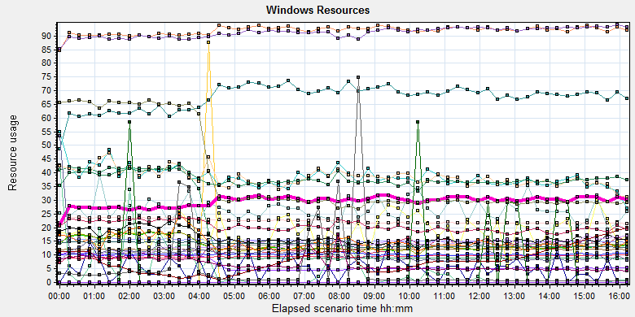

|  |  |  |  |  |  |  |  |  |  |  |  |  |  |  |  |  |  |  |  |  |  |  |  |  |  |  |  |  |  |  |  |  |  |  |  |  |  |  |  |  |  |  |  |  |  |  |  |  |  |  |  |  |  |  |  |  |  |  |  |  |  |  |  |  |  |  |  |  |  |  |  |  |  |  |  |  |  |  |  |  |  |  |  |  |  |  |  |  |  |  |  |  |  |  |  |  |  |  |  |  |  |  |  |  |  |  |  |  |  |  |  |  |  |  |  |  |  |  |  |  |  |  |  |  |  |  |  |  |  |  |  |  |  |  |  |  |  |  |  |  |  |  |  |  |  |  |  |  |  |  |  |  |  |  |  |  |  |  |  |  |  |  |  |  |  |  |  |  |  |  |  |  |  |  |  |  |  |  |  |  |  |  |  |  |  |  |  |  |  |  |  |  |  |  |  |  |  |  |  |  |  |  |  |  |  |  |  |  |  |  |  |  |  |  |  |  |  |  |  |  |  |  |  |  |  |  |  |  |  |  |  |  |  |  |  |  |  |  |  |  |  |  |  |  |  |  |  |  |  |  |  |  |  |  |  |  |  |  |  |  |  |  |  |  |  |  |  |  |  |  |  |  |  |  |  |  |  |  |  |  |
| --- | --- | --- | --- | --- | --- | --- | --- | --- | --- | --- | --- | --- | --- | --- | --- | --- | --- | --- | --- | --- | --- | --- | --- | --- | --- | --- | --- | --- | --- | --- | --- | --- | --- | --- | --- | --- | --- | --- | --- | --- | --- | --- | --- | --- | --- | --- | --- | --- | --- | --- | --- | --- | --- | --- | --- | --- | --- | --- | --- | --- | --- | --- | --- | --- | --- | --- | --- | --- | --- | --- | --- | --- | --- | --- | --- | --- | --- | --- | --- | --- | --- | --- | --- | --- | --- | --- | --- | --- | --- | --- | --- | --- | --- | --- | --- | --- | --- | --- | --- | --- | --- | --- | --- | --- | --- | --- | --- | --- | --- | --- | --- | --- | --- | --- | --- | --- | --- | --- | --- | --- | --- | --- | --- | --- | --- | --- | --- | --- | --- | --- | --- | --- | --- | --- | --- | --- | --- | --- | --- | --- | --- | --- | --- | --- | --- | --- | --- | --- | --- | --- | --- | --- | --- | --- | --- | --- | --- | --- | --- | --- | --- | --- | --- | --- | --- | --- | --- | --- | --- | --- | --- | --- | --- | --- | --- | --- | --- | --- | --- | --- | --- | --- | --- | --- | --- | --- | --- | --- | --- | --- | --- | --- | --- | --- | --- | --- | --- | --- | --- | --- | --- | --- | --- | --- | --- | --- | --- | --- | --- | --- | --- | --- | --- | --- | --- | --- | --- | --- | --- | --- | --- | --- | --- | --- | --- | --- | --- | --- | --- | --- | --- | --- | --- | --- | --- | --- | --- | --- | --- | --- | --- | --- | --- | --- | --- | --- | --- | --- | --- | --- | --- | --- | --- | --- | --- | --- | --- | --- | --- | --- | --- | --- | --- | --- | --- | --- | --- | --- | --- | --- | --- | --- | --- | --- | --- | --- | --- | --- | --- | --- |
| |  |  |  |  |  |  |  | | --- | --- | --- | --- | --- | --- | --- | | **Color** | **Scale** | **Measurement** | **Minimum** | **Average** | **Maximum** | **Std. Deviation** | |  | 0.0001 | Cursor memory usage (MSSQL$GCPACSWS|Cursor Manager by Type \_Total):10.184.129.208 | 40952 | 63360.729 | 119896 | 22300.092 | |  | 10 | Cursor Requests/sec (MSSQL$GCPACSWS|Cursor Manager by Type \_Total):10.184.129.208 | 0 | 1.725 | 11.624 | 1.699 | |  | 10 | Distributed Query (MSSQL$GCPACSWS|Exec Statistics Average execution time (ms)):10.184.129.208 | 0 | 1.218 | 138 | 2.417 | |  | 10000 | Distributed Query (MSSQL$GCPACSWS|Exec Statistics Cumulative execution time (ms) per second):10.184.129.208 | 0 | 0 | 3 | 0.021 | |  | 1000 | Distributed Query (MSSQL$GCPACSWS|Exec Statistics Execs in progress):10.184.129.208 | 0 | 0.005 | 1 | 0.071 | |  | 1E-17 | Distributed Query (MSSQL$GCPACSWS|Exec Statistics Execs started per second):10.184.129.208 | 0 | 2.6452747030728E+18 | 1.84467440737095E+19 | 6.46523218434761E+18 | |  | 1 | Errors/sec (MSSQL$GCPACSWS|SQL Errors \_Total):10.184.129.208 | 0.332 | 12.114 | 35.465 | 2.829 | |  | 10 | Errors/sec (MSSQL$GCPACSWS|SQL Errors User Errors):10.184.129.208 | 0 | 9.188 | 17.904 | 2.288 | |  | 1 | Extended Procedures (MSSQL$GCPACSWS|Exec Statistics Average execution time (ms)):10.184.129.208 | 0 | 0 | 0 | 0 | |  | 0.1 | Full Scans/sec (MSSQL$GCPACSWS|Access Methods):10.184.129.208 | 29.905 | 223.604 | 1143.341 | 92.677 | |  | 0.001 | Index Searches/sec (MSSQL$GCPACSWS|Access Methods):10.184.129.208 | 3395.136 | 15300.271 | 38697.73 | 6739.846 | |  | 1000 | Latch waits/sec (MSOLAP$GCPACSWS|Locks):10.184.129.208 | 0 | 0.018 | 0.997 | 0.079 | |  | 1000 | Lazy writes/sec (MSSQL$GCPACSWS|Buffer Manager):10.184.129.208 | 0 | 0.004 | 3.648 | 0.062 | |  | 1E-05 | Lock Requests/sec (MSSQL$GCPACSWS|Locks \_Total):10.184.129.208 | 227115.326 | 947281.33 | 1236414.83 | 118558.877 | |  | 0.1 | Lock Timeouts/sec (MSSQL$GCPACSWS|Locks \_Total):10.184.129.208 | 0 | 130.292 | 3530.06 | 55.042 | |  | 0.0001 | Lock Wait Time (ms) (MSSQL$GCPACSWS|Locks \_Total):10.184.129.208 | 0 | 136013.471 | 1342818.777 | 94451.714 | |  | 0.01 | Lock waits (MSSQL$GCPACSWS|Wait Statistics Average wait time (ms)):10.184.129.208 | 0 | 1632.613 | 25392 | 1614.378 | |  | 0.1 | Lock waits (MSSQL$GCPACSWS|Wait Statistics Waits in progress):10.184.129.208 | 0 | 136.758 | 416 | 63.766 | |  | 1 | Lock Waits/sec (MSSQL$GCPACSWS|Locks \_Total):10.184.129.208 | 0 | 67.544 | 178.124 | 25.24 | |  | 1 | Log write waits (MSSQL$GCPACSWS|Wait Statistics Average wait time (ms)):10.184.129.208 | 0 | 10.299 | 48 | 4.915 | |  | 0.1 | Logical Connections (MSSQL$GCPACSWS|General Statistics):10.184.129.208 | 93 | 203.547 | 304 | 22.783 | |  | 100 | Logins/sec (MSSQL$GCPACSWS|General Statistics):10.184.129.208 | 0 | 0.384 | 12.264 | 0.519 | |  | 100 | Logouts/sec (MSSQL$GCPACSWS|General Statistics):10.184.129.208 | 0 | 0.383 | 11.31 | 0.539 | |  | 1 | Lookups/sec (MSOLAP$GCPACSWS|Cache):10.184.129.208 | 0 | 0 | 0 | 0 | |  | 10 | Number of Deadlocks/sec (MSSQL$GCPACSWS|Locks \_Total):10.184.129.208 | 0 | 2.954 | 11.273 | 1.583 | |  | 0.1 | OLEDB calls (MSSQL$GCPACSWS|Exec Statistics Average execution time (ms)):10.184.129.208 | 0 | 137.128 | 2289 | 155.165 | |  | 1 | Page IO latch waits (MSSQL$GCPACSWS|Wait Statistics Average wait time (ms)):10.184.129.208 | 0 | 14.586 | 487 | 25.512 | |  | 10000 | Page latch waits (MSSQL$GCPACSWS|Wait Statistics Waits in progress):10.184.129.208 | 0 | 0 | 2 | 0.026 | |  | 0.001 | Page life expectancy (MSSQL$GCPACSWS|Buffer Manager):10.184.129.208 | 466 | 8017.181 | 20394 | 4570.357 | |  | 0.0001 | Page lookups/sec (MSSQL$GCPACSWS|Buffer Manager):10.184.129.208 | 257038.047 | 911989.991 | 1102880.447 | 99337.059 | |  | 1 | Page reads/sec (MSSQL$GCPACSWS|Buffer Manager):10.184.129.208 | 0 | 5.308 | 6920.548 | 99.407 | |  | 1 | Page writes/sec (MSSQL$GCPACSWS|Buffer Manager):10.184.129.208 | 0 | 6.514 | 1278.141 | 25.428 | |  | 10 | Safe Auto-Params/sec (MSSQL$GCPACSWS|SQL Statistics):10.184.129.208 | 0 | 3.884 | 14.613 | 2.03 | |  | 0.1 | SQL Compilations/sec (MSSQL$GCPACSWS|SQL Statistics):10.184.129.208 | 55.137 | 137.459 | 197.958 | 13.2 | |  | 1000 | SQL Re-Compilations/sec (MSSQL$GCPACSWS|SQL Statistics):10.184.129.208 | 0 | 0.011 | 1.331 | 0.063 | |  | 1 | Total deadlocks detected (MSOLAP$GCPACSWS|Locks):10.184.129.208 | 0 | 0 | 0 | 0 | |  | 1 | Transactions (MSSQL$GCPACSWS|Transactions):10.184.129.208 | 6 | 37.611 | 257 | 9.507 | |  | 0.1 | User Connections (MSSQL$GCPACSWS|General Statistics):10.184.129.208 | 93 | 203.538 | 304 | 22.782 | |  | | | | | | | |

Figure 3.7.2.1 Database result

Following the SQL server monitor resource, we can find the Database has some issues that make the system reliability not well:

There are cursors operations exist in the database:

|  |  |  |  |  |  |  |
| --- | --- | --- | --- | --- | --- | --- |
|  | 0.0001 | Cursor memory usage (MSSQL$GCPACSWS|Cursor Manager by Type \_Total):10.184.129.208 | 40952 | 63360.729 | 119896 | 22300.092 |
|  | 10 | Cursor Requests/sec (MSSQL$GCPACSWS|Cursor Manager by Type \_Total):10.184.129.208 | 0 | 1.725 | 11.624 | 1.699 |

Database does the cursor operations every 1.7/ seconds. SQL server suggests users to do the operation base on column data. Please indentify the SQL statement and do some enhance works.

There are some error happens during the testing work:

|  |  |  |  |  |  |  |
| --- | --- | --- | --- | --- | --- | --- |
|  | 1 | Errors/sec (MSSQL$GCPACSWS|SQL Errors \_Total):10.184.129.208 | 0.332 | 12.114 | 35.465 | 2.829 |
|  | 10 | Errors/sec (MSSQL$GCPACSWS|SQL Errors User Errors):10.184.129.208 | 0 | 9.188 | 17.904 | 2.288 |

Database has 12.1 errors every second and 9.1/ records are user errors. It maybe cause by the dead lock or other issues.

There are too many full scans operations exist in the database:

|  |  |  |  |  |  |  |
| --- | --- | --- | --- | --- | --- | --- |
|  | 0.1 | Full Scans/sec (MSSQL$GCPACSWS|Access Methods):10.184.129.208 | 29.905 | 223.604 | 1143.341 | 92.677 |

Database has full scans issues and average value is 223/sec. This issue will result in the SQL statement executes slowly because it does not use the index. Some operations will cause the full scans such as select count (\*), use <> and! =, use like fuzzy query etc. Please enhance the SQL statement performance ASAP.

There are many locks and deadlocks issues exist in the database:

|  |  |  |  |  |  |  |
| --- | --- | --- | --- | --- | --- | --- |
|  | 1E-05 | Lock Requests/sec (MSSQL$GCPACSWS|Locks \_Total):10.184.129.208 | 227115.326 | 947281.33 | 1236414.83 | 118558.877 |
|  | 0.1 | Lock Timeouts/sec (MSSQL$GCPACSWS|Locks \_Total):10.184.129.208 | 0 | 130.292 | 3530.06 | 55.042 |
|  | 0.0001 | Lock Wait Time (ms) (MSSQL$GCPACSWS|Locks \_Total):10.184.129.208 | 0 | 136013.471 | 1342818.777 | 94451.714 |
|  | 0.01 | Lock waits (MSSQL$GCPACSWS|Wait Statistics Average wait time (ms)):10.184.129.208 | 0 | 1632.613 | 25392 | 1614.378 |
|  | 0.1 | Lock waits (MSSQL$GCPACSWS|Wait Statistics Waits in progress):10.184.129.208 | 0 | 136.758 | 416 | 63.766 |
|  | 1 | Lock Waits/sec (MSSQL$GCPACSWS|Locks \_Total):10.184.129.208 | 0 | 67.544 | 178.124 | 25.24 |
|  | 10 | Number of Deadlocks/sec (MSSQL$GCPACSWS|Locks \_Total):10.184.129.208 | 0 | 2.954 | 11.273 | 1.583 |

We can see that the average lock waits time is 0.136 seconds and timeouts average value is 0.136 seconds. There are 67 locks and 209 deadlocks every second. The database design is not well, the deadlocks makes many test transactions failed. We should find out them and fix it as the high level tasks.

There are about 203 database connections in the database, but login and logout frequency is 0.33/sec. Can we reduce the connection number?

|  |  |  |  |  |  |  |  |  |
| --- | --- | --- | --- | --- | --- | --- | --- | --- |
|  | | 0.1 | Logical Connections (MSSQL$GCPACSWS|General Statistics):10.184.129.208 | 93 | 203.547 | 304 | 22.783 | |
|  | | 100 | Logins/sec (MSSQL$GCPACSWS|General Statistics):10.184.129.208 | 0 | 0.384 | 12.264 | 0.519 | |
|  | | 100 | Logouts/sec (MSSQL$GCPACSWS|General Statistics):10.184.129.208 | 0 | 0.383 | 11.31 | 0.539 | |
|  | | 0.1 | User Connections (MSSQL$GCPACSWS|General Statistics):10.184.129.208 | 93 | 203.538 | 304 | 22.782 | |
| Description: C:\Users\Administrator\Desktop\Performance result\20170531_1\Report\dot_trans.gif | | | | | | |

## Test Error

There are some errors exist in the testing work and logged as follow:

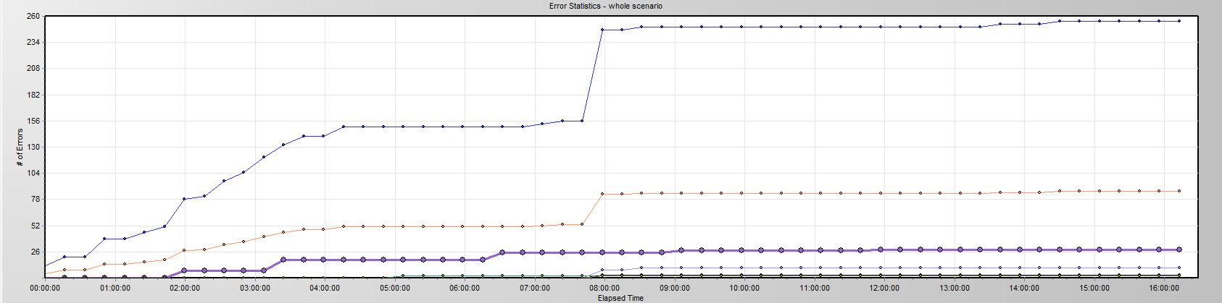

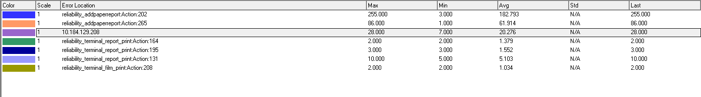

|  |  |  |
| --- | --- | --- |
| No | description | Counts |
| 1 | "HttpSendRequest" failed, Windows error code=12002 and retry limit (0) exceeded for URL="http://10.184.129.208/NotifyServer/NotifyService.asmx" | 85 |
| 2 | No match found for the requested parameter "ServiceResult". Check whether the requested boundaries exist in the response data. Also, if the data you want to save exceeds 256 bytes, use web\_set\_max\_html\_param\_len to increase the parameter size | 85 |
| 3 | The above "not found" error(s) may be explained by header and body byte counts being 0 and 0, respectively. | 85 |
| 4 | Add patient reports failed by using NotifyReportFile service, please reference the service is works well or not. The accn is A\*\*\*\*\*\*\*\*\*\* | 88 |
| 5 | Error -- memory violation : Exception ACCESS\_VIOLATION received. | 15 |

Error analyzes:

1. Http request do not execute successfully, need team to identify the reason of that. It may be caused by the lock or service error.
2. There is no response come from the PS service, perhaps caused by the IIS services.
3. Same as step2.
4. The services do not return the excepted response content, the service is down or the expiation catch function does not work.
5. Cause by the test tool, not error.

## Test Conclusion

Developer team has made some enhance works on this tested version for PS system. Reference the performance test result, the performance and reliability has enhanced. But there are still exist these issues need to update.

1. The “NotifyService” service needs to enhance. There are 86 transactions failed during the testing work. It will be the victims of the dead lock from database. We indentify the detail information from the log file:

2017-07-16 16:40:52,773 FATAL - ----------Exception----------

事务(进程 ID 139)与另一个进程被死锁在 锁 | 通信缓冲区 资源上，并且已被选作死锁牺牲品。请重新运行该事务。

在 System.Data.SqlClient.SqlConnection.OnError(SqlException exception, Boolean breakConnection, Action`1 wrapCloseInAction)

在 System.Data.SqlClient.TdsParser.ThrowExceptionAndWarning(TdsParserStateObject stateObj, Boolean callerHasConnectionLock, Boolean asyncClose)

在 System.Data.SqlClient.TdsParser.TryRun(RunBehavior runBehavior, SqlCommand cmdHandler, SqlDataReader dataStream, BulkCopySimpleResultSet bulkCopyHandler, TdsParserStateObject stateObj, Boolean& dataReady)

在 System.Data.SqlClient.SqlCommand.RunExecuteNonQueryTds(String methodName, Boolean async, Int32 timeout, Boolean asyncWrite)

在 System.Data.SqlClient.SqlCommand.InternalExecuteNonQuery(TaskCompletionSource`1 completion, String methodName, Boolean sendToPipe, Int32 timeout, Boolean asyncWrite)

在 System.Data.SqlClient.SqlCommand.ExecuteNonQuery()

在 BaseComponent.DBUtility.ExecuteSql(String db\_name, String sql) at:BaseComponent.PrintUtility.UpdatePaitentInfo-Line:0

1. There are many waits and locks exist in the database. We need update these issues as first. The detail SQL statement, please reference the performance testing reports.

We execute the whole testing works for 16 hours, it does not meet the requirements of test plan. Because the team has the plan to fix the performance issues first, the current version is not the final testing one. Following current test result, our core function module is not reliable. Sometimes it will fail because of the deadlock:

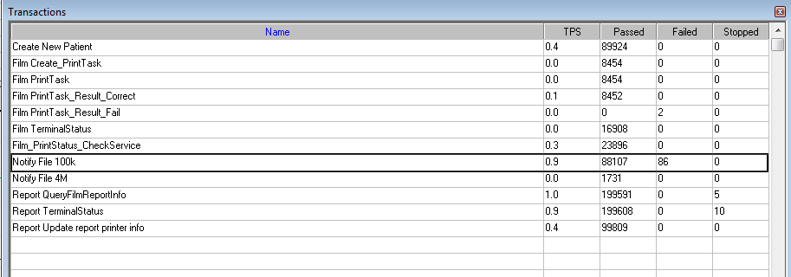

However, we have made some progress on performance and reliability works. It confirms that the tuning operations worked; team should keep going on it.

After team finish the performance tuning works, we will continue the reliability testing works. The result of reliability testing works is failed because it does not meet the requirement as current version.

Describe the overall verification and validation testing objectives.

Please make appropriate modifications to the sample text so it accurately reflects this project.

**<End of Document>**